15.24: (a) 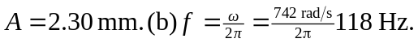 (c)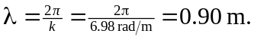 (d) 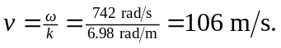 (e) The wave is traveling in the –x direction because the phase of y (x,t) has the form 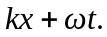 (f) The linear mass density is , so the tension is (keeping an extra figure in for accuracy).
